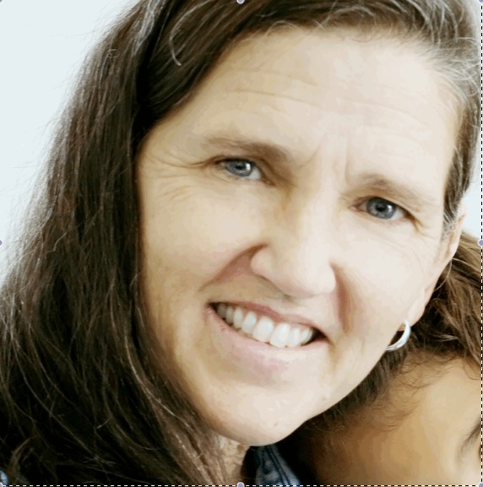

Let me introduce myself…..

I am Mary Camarata, a speech pathologist with more than 40 years experience teaching children with a wide variety of abilities, including giftedness, exceptional learners, language disorder, Autism, and cognitive disabilities. In addition to assisting families and schools across the country in making eligibility, placement and goal selection, I have coordinated numerous federally funded research projects on language & learning, inclusion, resource, and self-contained intervention models at Peabody College and Vanderbilt University School of Medicine. In this capacity I have been an author on more than 30 scholarly papers appearing in peer reviewed journals.
Over the past years I have held positions at Pennsylvania State University, University of California Santa Barbara, and Vanderbilt University. More recently, I have been assisting with the development of new tests for the Woodcock-Johnson Tests of Cognitive Abilities and Achievement. I am also in private practice assisting families whose children are experiencing developmental delays have successful outcome in their home, school, and other daily environments. Finally, I am the mother of seven children, including one who had an IEP from preschool through middle school.

Mary N. Camarata, M.S., CCC-SLP
Speech-Language Pathologist
Developmental Research Associate

